|  |  |
| --- | --- |
| Original Prototype | Updated Prototype |
| Menu Page | |
|  |  |
| Create Match page | |
|  |  |
| Adding Players to match | |
|  |  |
| Player adding error popup | |
|  |  |
| Team 1 Player adding page |  |
|  |  |
| Team 2 Player adding page |  |
|  |  |
| Player details adding page |  |
|  |  |
| Added player display | |
|  |  |
| Player delete popup message | |
|  |  |
| Match Start Page |  |
|  |  |
| Match Recording Page | |
|  |  |
| Match recording stop page | |
|  |  |
| Match Action Page | |
|  |  |
| Match action error popup | |
|  |  |
| Match Stat Page | |
|  |  |
| Match Score worm page | |
|  |  |
| All players summary | |
|  |  |
| Players comparison page | |
|  |  |
| History of match display page | |
|  |  |

**Prototypes that only have in updated prototype**

History of match display this is similar to the recording stat prototype only difference is history of prototypes do not have red live recording buttons. This prototype clearly shows the winner of the match.

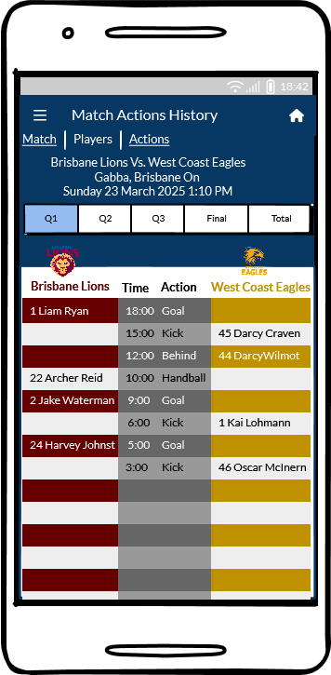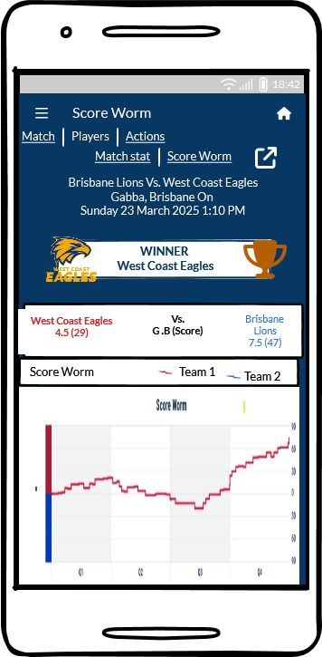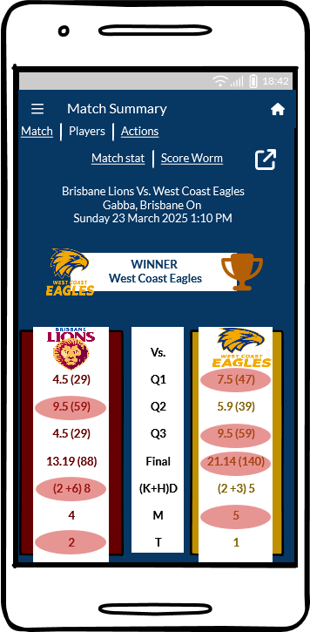

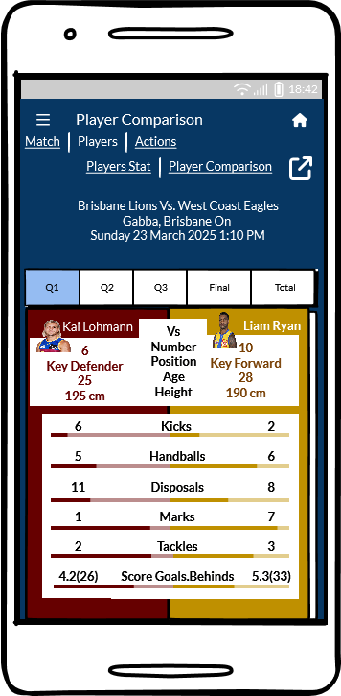

**Team ranks as custom feature**

